Experiment 16
Aim
To implement a Feed Forward Neural Network (FFNN) in Python for classification using the scikit-learn library.
Algorithm:
- Start
- Collect the input dataset and corresponding output labels.
- Divide the dataset into training and testing data.
- Initialize the neural network with an input layer, hidden layer, and output layer.
- Assign weights and biases to the connections between neurons.
- Pass the input data from the input layer to the hidden layer.
- Apply an activation function such as ReLU.
- Pass the output of the hidden layer to the output layer.
- Calculate the predicted output.
- Compare the predicted output with the actual output.
- Calculate the error and update the weights during training.
- Repeat the process until the model is trained.
- Use the trained network to predict the output for test data.
- Calculate and display the accuracy.
- Stop.
Code:
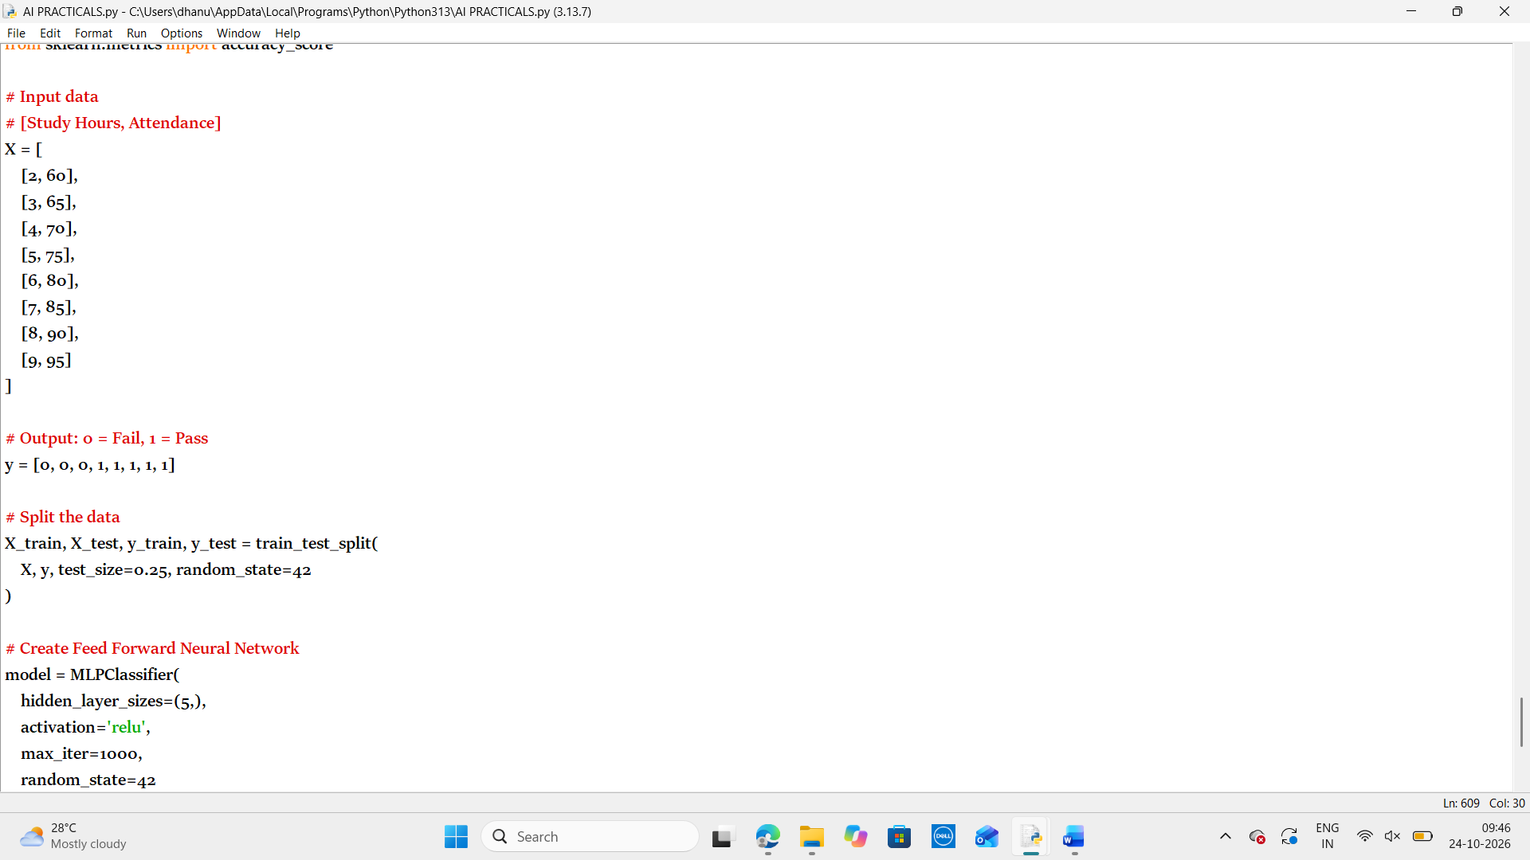
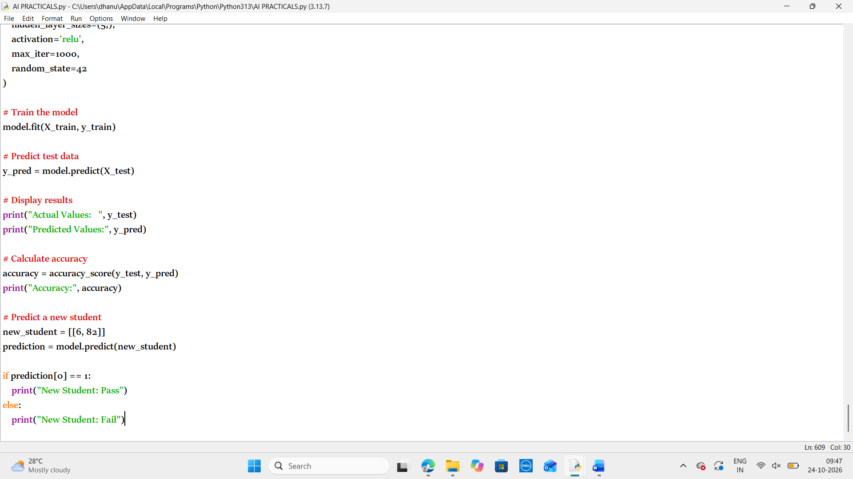
Output:
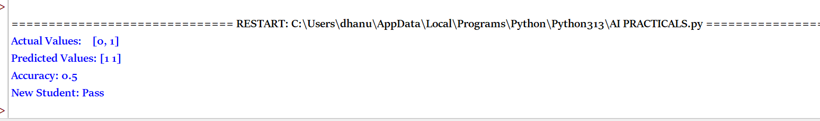
Result:
Thus the python program to implement a Feed Forward Neural Network (FFNN) in Python for classification using the scikit-learn library

